**State Level Overview of the demand**

Demand is the units sold in each store.

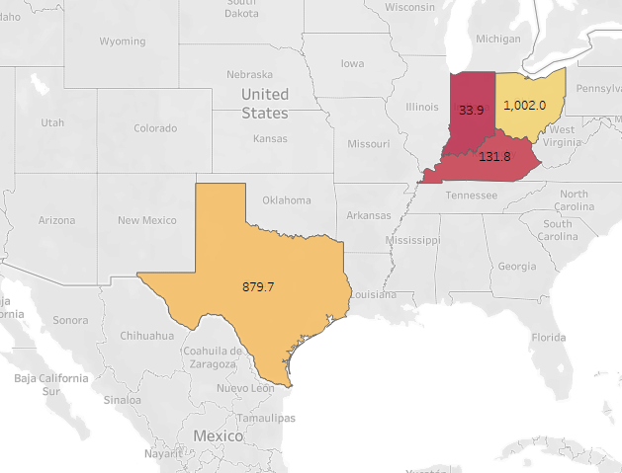

There data consist of 4 states, they are basically Texas, Kentucky, Indiana, Ohio.

At a high level we wanted to know the average demand per state, so here we can see that the average demand is high for Ohio whereas least is in Indiana, it has only one store. Hence it does make any sense to consider it as least, Kentucky is least compared to ohio.

**Demand per state Per segment:**

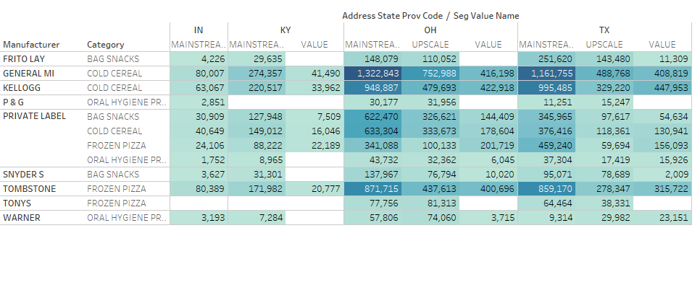

The demand is further drill down to segment wise, here there are 3 segments in which it varies depends on the area. So basically,

* Upscale stores: Located in high income neighborhoods and offer more high-end product.
* Mainstream stores: located in middle class areas, offering a mix of upscale and value product.
* Value Stores: Focus on low prices products targeting low income customers.

From the above chart we can see that, “OH” state demand is more in Mainstream segment followed by TX. This gives the insights like major chunk of the populations are middle class people and hence the demand is high.

Dollar Share:

* Major chuck of the share in cold cereal, all family cereals it is contributions 70%, since bag snacks.
* Conversely, adult cereal dollars demand is very less.

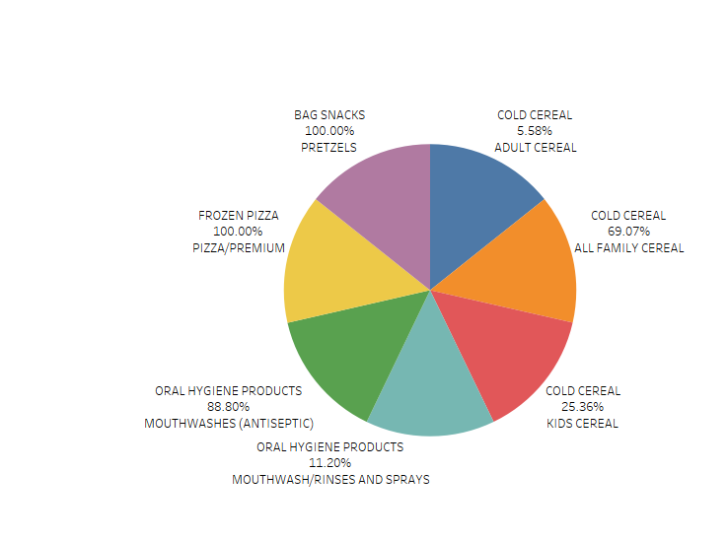

Unit Share: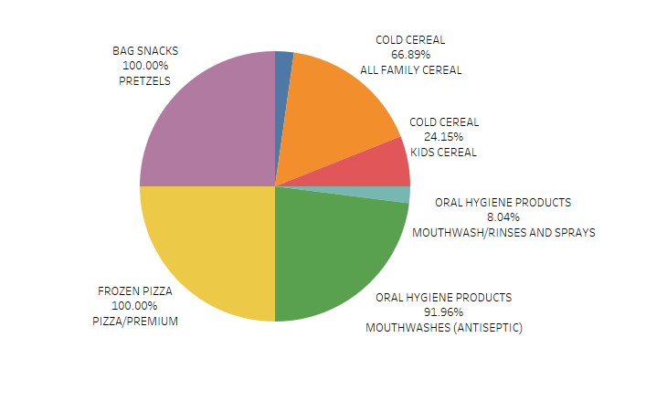

Comparing the dollar share and unit share are one and on, as you can see the as the more the unit sold and the more it is contributing to the share.

**Demand by product size:**

Till now we have seen the impact of demand on the high level, now let dig deep into the lowest level,

* Bag snacks has 1 sub-category and 3 product size available like 15 Oz,16 Oz,10 Oz.
* Oral Hygiene product has 2 subcategories and 2 size options like 500ml , Iltr
* Frozen pizza has only 1 subcategory and 6 different package size.
* Cold cereal has 3 subcategory and 6 options in size.

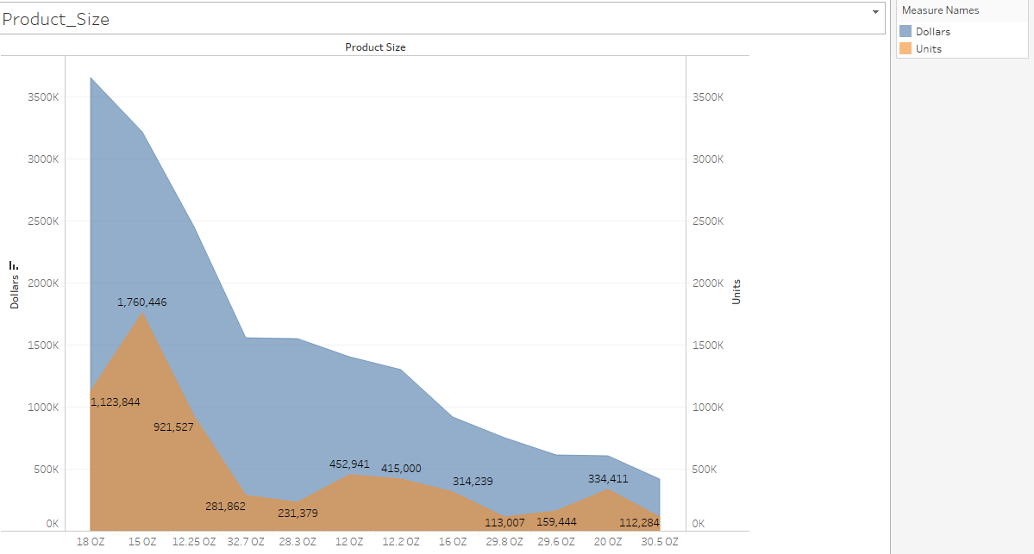

The is a acute spike in sales when the product size is medium say 18oz to 15 oz, since people are more interested to buy the product with less product size, conversely we can see that the sales for the product size with high is very less as compared to medium.

Comparison with Latest Year:

* This gives an overview of the product performance compared to prior year, since the data is of 2009 to 2011, considered latest year as 2011 and prior year as 2010.
* The average of the prior and latest year is done using LOD expressions. As shown below,

For latest year,

IF{MAX(YEAR([Week End Date]))}= YEAR([Week End Date]) then [Units]

ELSE 0

END

For prior year,

IF{MAX(YEAR([Week End Date]))}-1= YEAR([Week End Date]) then [Units]

ELSE 0

END

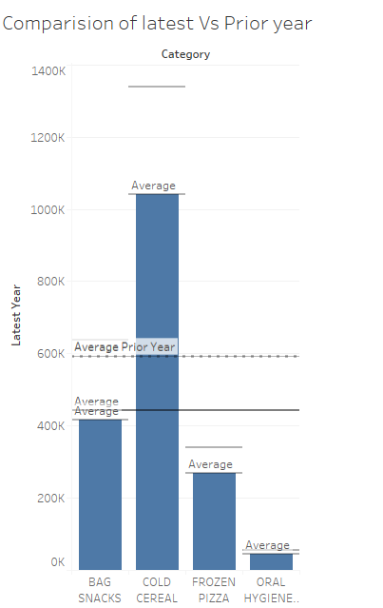

This will give an idea how my category is comparing with respect to prior year.

Most of the categories are less than the average of the prior . hence this needs to improved.

**Demand based on the descriptions**

So here the demand is segregated into three different categories based in the threshold,

If the demand is more than 450 k then it is called as high demand products it is segregated using “Group” similarly if the demand is less than 150K then it s known as low demand, the major chunk of the demand is lower demand.

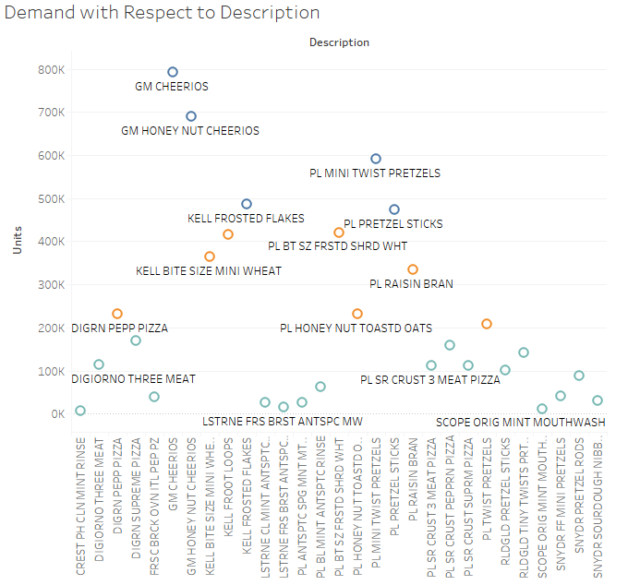

Interestingly the frozen foods are with lower demand, this might be because of the data of availability as well as there might be the chances of the expiring data. Hence the low units leads to less demand.

Sales By Area:

* Upscale stores: Located in high income neighborhoods and offer more high-end product.
* Mainstream stores: located in middle class areas, offering a mix of upscale and value product.
* Value Stores: Focus on low prices products targeting low income customers
* So from the bar graph, we can see that the mainstream doesn’t operates for the sales area between 64k to 80K, whereas that chunk is operated by upscales, hence the more the area the more the scope for upscale.

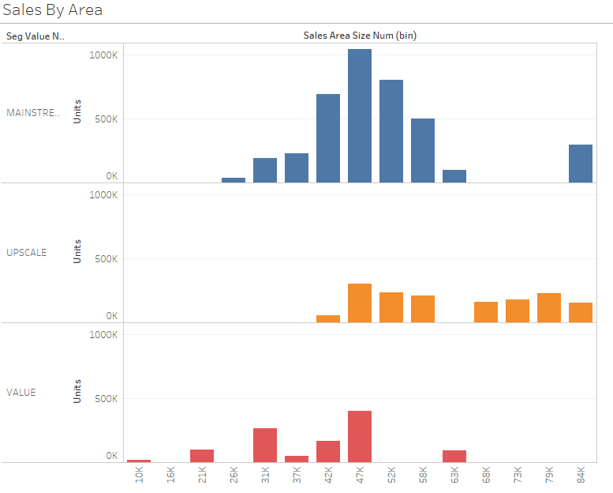

* Whereas It is converse when you check for value stores, there is no specific trend as such, but there are few spikes which emphasis that people are low incomed group hence the demand is also minimal.
* On a whole, mainstream stores is normally distributed in terms of demand, so we can say that the major demand is from the sales area 37k to 60K.
* This would the other view for the demand, where in size of the store is more or less is directly impacts the average units in the store.

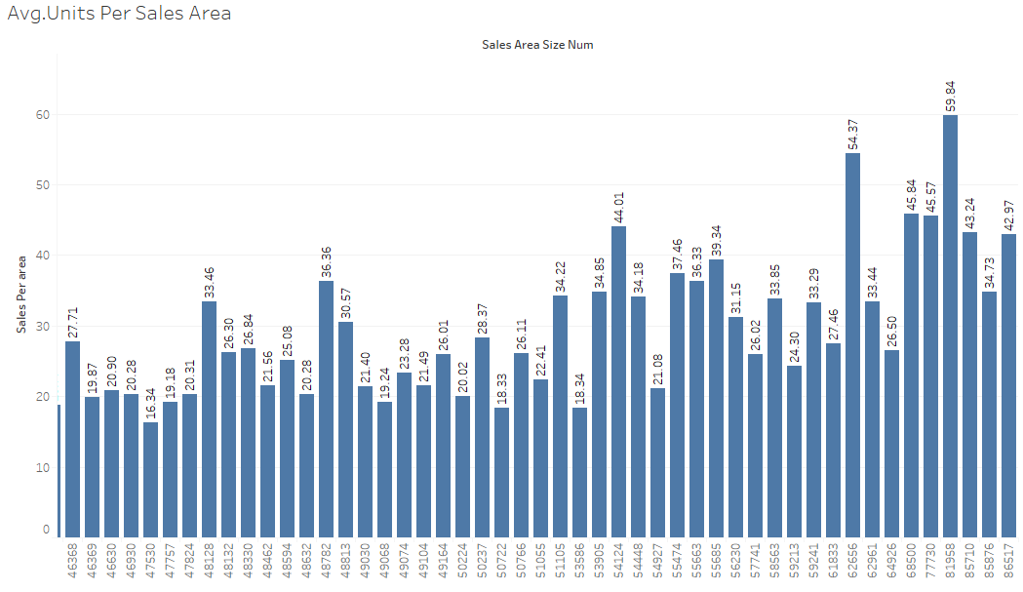

**Units Per Square Foot & Dollars Per Square Foot:**

* It helps the stores to determine the revenue generated per square foot of retail space.
* It is used to know the sales efficiency of the retail stores.

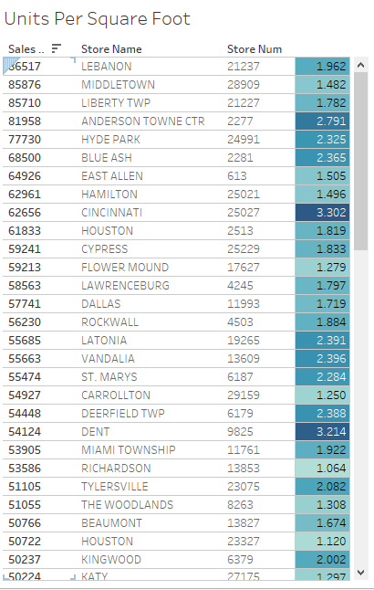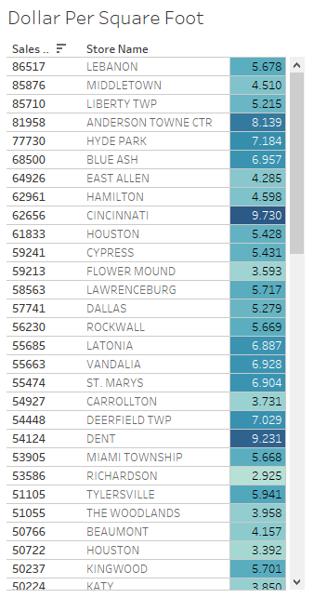

* Poor sales per square foot could be due to the products that are unappealing to the customers.
* From the above we can see that, the is a no correlation of size of the area and demand, there might be the chances of no effective utilization of the spaces in the store, where the units are greater than 3 the revenue for the square foot is increased. Conversely if the Units per square foot is less than the chances of revenue are less per square foot.
* Hence this would help the retailer to know the efficiency of the store.

**Average Weekly Basket:**

* Number of items getting sold in the single purchase.
* This figure can be influenced by offering volume discounts, point of sale promotions, and personal recommendations by the retailers.
* Keeping a variety of products and having all the sizes available also contributes in increasing the average ticket size.

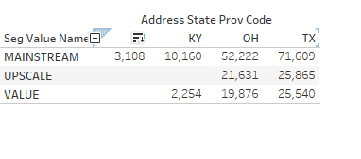

* From the above, most the store in TX occupy mainstream segment.
* The same you can you from the below graph in state wise and city wise.
* The inference we can draw here is the average weekly basket value is more in main stream segment, since it caters to the most of the people with middle income.
* Hence demand is optimal, due to which the replenishment of the stock should be maintain appropriate, there could be the least chances

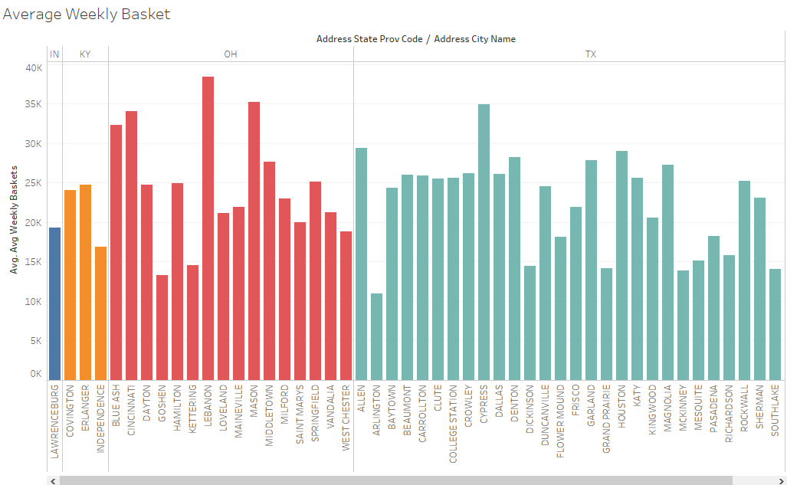

* Upscale: 60000 sales area with 29000 average weekly baskets
* Mainstream:50000 sales area with 25000 average weekly baskets
* Value: 39000 sales area with 22000 average weekly baskets

We can infer that more the sales area, more the chances of increasing the product reach hence the more average baskets sold per week would be high.